**Hybrid or Custom Agile Lab Experimentation**

1.Create a new project as company managed one and provide the unique name for it.

2.Open issues from settings and add the new issues with proper description.

3.Now open custom fields and create a required field with proper dropdown options.

4. Create the epic in the Current board and provide the description Change the workflow according to the agile model.

5.Now type the issues in backlog with proper details and status of the issue.

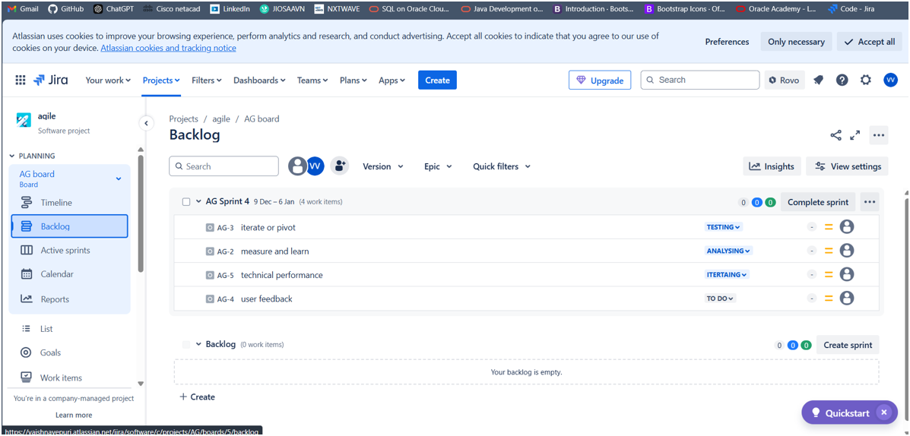

6. Drag the issues from backlog to the sprint created.

7.Click start sprint and let it execute. Now click the complete sprint and it displays the number of issues in different statuses like to do, iterating,etc.

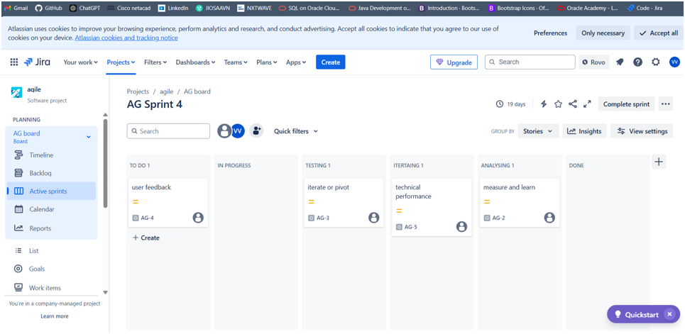

8.Now click active sprints in left slidebar to check the currently running sprints. 9.Now click on list from left slidebar to check the list of issues and to check progress of the project.

